AirBird is a domestic airline company that is building a Customer Relationship Management (CRM) system that focuses on providing a personalized experience to all customers. The system would be deployed on mobile phones, tablets and desktop. Customers will be allowed to search for flights, view flight routes and itineraries, filter flights based on price, destination, duration, number of stops, class (basic economy, economy, business and first class). Customers will need an account with AirBird to book a trip or purchase flights. They should be able to view past trips, print the itinerary for an upcoming trip and modify or cancel trips. If a customer wants to modify a flight, there is no service charge, except that the customer will have to pay a price difference if the prices on the new date are higher. If the prices have gone down, the customer will receive a gift card from AirBird called “AirBird Wallet”. The wallet has no expiry and the money in the wallet can be used for future purchases.

AirBird also has a rewards program based on flyer miles and miles expire after 5 years since they were accrued. Both the wallet and the rewards can be used to purchase tickets, make upgrades (economy to business class), avail discounts at lounges and purchase in-flight items. The main difference is that the wallet has no expiry and the miles expire after 5 years. The CRM system will allow the customer to select preferences on seating, food and drinks. The system should include the ‘Language Change’ functionality that allows the customer to choose the preferred language. Customer should get promotional emails based on their search history. The system should allow the customer to make payments via credit cards, PayPal and AirBird wallet.

Here are two possible class diagrams. Both are detailed enough and clearly convey the classes for this case.

Solution 1:

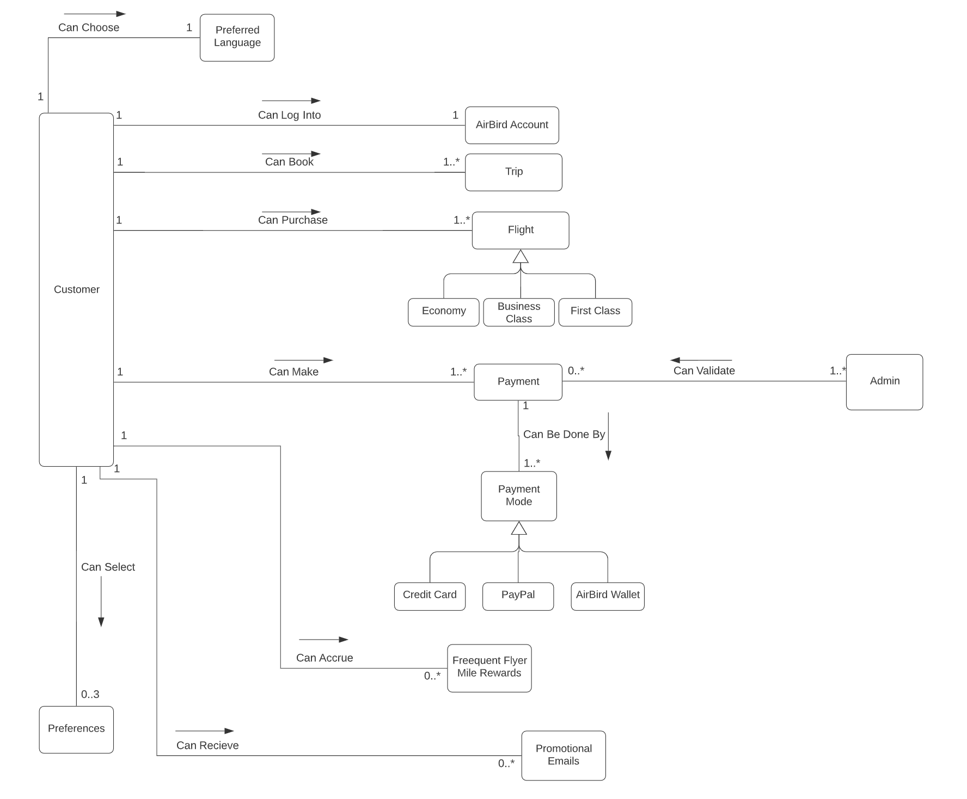

Solution 2:

